The Hidden Architecture of Wikipedia
A Social Network Analysis of Editor Collaboration in the English Wikipedia Artificial Intelligence Article Cluster (2018 to 2025)
Arda Astam
Koc University
Department of Computational Social Science
Abstract
This study examines the social structure that lies beneath knowledge production on Wikipedia. Specifically, it looks at the co-editing network formed by contributors to the Wikipedia Artificial Intelligence article cluster between 2018 and 2025. Drawing on 20,636 revision records retrieved through the MediaWiki API, the analysis builds a weighted graph of 467 nodes and 3,705 edges, where editors are nodes and shared article contributions form the edges. The methodology combines four centrality measures Louvain community detection, the Watts-Strogatz small-world test, a hub removal robustness simulation, and yearly cohort analysis.
Five main findings emerge. First, the network is dominated by two editors, Maxeto0910 and Jarble, who are the top two positions across all four centrality metrics. Second, the network does not exhibit small world properties (sigma = 0.21), and instead displays a clear core periphery topology. Third, removing only Maxeto0910 causes the network to fragment into 19 distinct components, signaling a high degree of structural fragility. Fourth, the editor population grew substantially during the 2023 to 2025 period, but newcomers have not been able to integrate into the existing community. Fifth, the 2025 cohort holds an average degree of just 5.8, roughly one eighth of the average degree observed in the 2018 cohort (46.1).
Keywords: social network analysis, Wikipedia, Artificial Intelligence, collaboration network, centrality, community detection, small world, ChatGPT effect.

1. Introduction
Wikipedia, with more than 60 million articles spanning over 60 languages, stands as the largest open collaboration platform in the world. Millions of users consult it every day. What makes it remarkable is that the entire content emerges from the collaborative work of thousands of volunteer editors, with no central authority directing the process. Yet this large scale participation is far from equally distributed. A recurring finding in the literature is that the majority of Wikipedia content is produced by a small, highly committed group of editors.
Artificial Intelligence is one of the fastest growing and most heavily visited subdomains on Wikipedia. In the past decade it has shifted from a relatively narrow academic field into a topic of broad public conversation. AI articles now face heavy pressure regarding scope, neutrality, and currency. Editorial conflicts and consensus building processes intensify around this domain. All of this makes it a particularly interesting case for study.
The November 2022 release of ChatGPT by OpenAI further amplified these dynamics. The concept of artificial intelligence moved from academic publications into everyday conversation almost overnight. Visible spikes in traffic and editing activity followed on Wikipedia AI pages. This situation provides a rare natural experiment for examining how an external shock reshapes open collaboration platforms.
This study addresses several questions. Who occupies the central positions in the Wikipedia AI co editing network? How do editors cluster into communities? Does the network show small world properties? What happens to the network if hub editors leave? And how has the network structure shifted between 2018 and 2025, particularly for newcomers entering after 2022?

2. Literature Review and Research Gap
2.1 Studies on Wikipedia Collaboration
Wikipedia's social structure has attracted research attention from its early years. Viegas, Wattenberg, and Dave (2004) developed the History Flow technique, which provided the first systematic visualization of Wikipedia revision histories. Their work revealed the cumulative and contested nature of content production and demonstrated the broader research potential of revision data.
Kittur, Chi, Pendleton, Suh, and Mytkowicz (2007) examined the asymmetric distribution of content contributions and identified what they called the 'power of the few' phenomenon on Wikipedia . According to their work, a small group of editors is responsible for the vast majority of content changes. This finding establishes the conceptual basis for the hub dominated structure observed in the present study.
Halfaker, Geiger, Morgan, and Riedl (2013) carried out a longitudinal study of Wikipedia editor retention. They documented that the active editor population peaked around 2007, followed by a clear decline. They attributed the decline largely to growing institutional barriers facing newcomers and the formalization of editorial norms. This pattern has direct relevance to the integration crisis observed in our cohort analysis.
Ren, Zhang, and Kraut (2023) offered a comprehensive review of the literature on collaboration and coordination among Wikipedia editors. Their synthesis emphasized that the majority of existing research focuses on article to article hyperlink networks, while editor to editor co editing networks remain comparatively underexplored.
2.2 Foundational Network Theory
Barabasi and Albert (1999) described scale free networks formed through preferential attachment. In such networks, the degree distribution follows a power law of the form P(k) proportional to k to the power negative gamma, and a small number of hub nodes dominate the connectivity. The gamma value of 0.96 observed in our network raises interesting questions about how cleanly this framework applies.
Watts and Strogatz (1998) introduced the small world network model. They showed that real social networks tend to combine high local clustering with short average path lengths. This framework forms the basis of our small world test.
On community detection, Blondel and colleagues (2008) developed the Louvain algorithm, a fast and scalable approach based on modularity optimization. Newman and Girvan (2004) proposed that a modularity Q value above 0.30 indicates meaningful community structure.
2.3 Studies on the ChatGPT Effect
Reeves, Yin, and Simperl (2024) analyzed Wikipedia engagement statistics from 2021 to 2024, looking for the impact of ChatGPT's release on overall platform activity . They reported no statistically significant general change in edit counts or editor numbers attributable to ChatGPT. This conclusion contrasts in important ways with our domain specific findings, which show substantial change within the AI cluster, and provides a useful comparison point.
Rychwalska and colleagues (2025) examined the interpersonal communication networks among Wikipedia editors. Their work suggests that high quality articles tend to emerge from groups whose communication patterns support both information sharing and integration. This finding offers a useful counterpoint to the core periphery structure observed here.

2.4 Research Gap
Three notable gaps in the existing literature motivate this study.
The first gap is that most network studies of Wikipedia focus on article to article hyperlink graphs. Research that places editor to editor co editing networks at the center, particularly in a domain specific context, remains limited.
The second gap concerns the dramatic transformation of the AI domain after 2022, including the rapid spread of large language models and the burst of editorial activity that followed. This shift has not yet been thoroughly examined in the literature. Reeves and colleagues, looked at general Wikipedia metrics, which is why they could not detect the domain specific effects.
The third gap relates to the structural roles of hub editors. While Kittur and colleagues 2007 confirmed the power of the few phenomenon, they did not analyze in detail whether hub editors function primarily as brokers, as authorities, or as both, using network theoretic tools. Furthermore, the structural fragility produced by hub dependency has only been studied to a limited extent through robustness tests.
2.5 Contribution of This Study
First, this study constructs a weighted editor co editing network specifically for the AI article cluster, providing a domain focused analysis that captures structural features which general Wikipedia studies cannot reveal.
Second, the yearly cumulative snapshot analysis between 2018 and 2025 tracks the impact of the ChatGPT inflection point on the structure of the network, not just on raw editor counts. Unlike Reeves and colleagues, who relied on aggregate engagement metrics, this work documents structural shifts in clustering, density, and cohort integration.
Third, the structural roles of hub editors are examined comparatively across all four centrality metrics. The robustness simulation quantifies the actual fragility produced by hub dependency.
3. Data and Method
3.1 Data Source
All data were obtained from the publicly available MediaWiki REST API using the Python. No authentication or special permission was required. All data available under Wikipedia's Creative Commons license.
3.2 Data Collection
Articles falling under the Category: Artificial Intelligence of the Wikipedia were scanned. Out of 242 candidate articles, 210 returned data successfully and 186 made it into the final analysis. For each article, up to 300 revisions were retrieved using the parameter prop equal to ids, user, and timestamp. This produced 49,755 raw revision records.
3.3 Data Cleaning
Bot removal: Accounts whose usernames contain 'bot' etc. were classified as automated and removed from the dataset. This step eliminated 221 bot accounts and 3,991 revisions.
Time: Revisions outside the study window of 2018 to 2025 were excluded.
Excluded articles (crowding filter): Five articles with very high editor counts were removed from the analysis: Artificial intelligence (1,504 editors), Artificial general intelligence (485), Game theory (460), Graphics processing unit (372), and Ethics of artificial intelligence (340). Two reasons motivated this decision. First, the so called 'collaboration' between hundreds of editors on these pages does not actually represent shared work. It mostly reflects individual interventions such as small fixes, vandalism reverts, and minor additions made over many years. Second, including these articles would add over 1.1 million edges, drowning out the genuine collaboration patterns. The complete list appears in Appendix A.
After cleaning, the final dataset contains 186 articles and 20,636 revisions.
3.4 Notes on Data
Bot detection based on usernames cannot catch semi automated accounts that lack obvious indicators in their names. This is one limitation of the current approach.
3.5 Network Construction
The co editing network was defined as an undirected, weighted graph G equal to (V, E). Here V is the set of nodes representing editors, and E is the set of edges representing pairs of editors who edited at least two common articles. Edge weight w(u,v) reflects the number of shared articles between editors u and v.
Filtering: Edges with weight 1 (only one shared article) were treated as accidental co occurrences and removed. This step preserves connections that reflect real collaboration. Isolated nodes were also removed, and the largest connected component was retained for analysis. The resulting network has 467 nodes and 3,705 edges.
3.6 Analysis Methods
Centrality analysis uses four complementary metrics. Degree centrality measures the proportion of total connections held by a node. Betweenness centrality, computed via the Brandes algorithm, captures how often a node sits on shortest paths between others. PageRank gives a recursive prestige score weighted by edge weights . Closeness centrality measures average proximity to other nodes.
Community detection is performed using the Louvain algorithm developed by Blondel and colleagues (2008). The algorithm maximizes the modularity Q value, with Q greater than 0.30 typically indicating meaningful community structure .
Small world testing follows the Watts Strogatz framework . The clustering coefficient (C) and average path length (L) of the real network are compared to those of a random Watts Strogatz graph with matching n and k parameters. The sigma coefficient is computed as (C divided by C_random) divided by (L divided by L_random). Sigma greater than 1 indicates small world topology.
Robustness testing removes the 20 editors with the highest betweenness centrality scores one by one. At each step the number of components and the size of the largest component are recorded. This approach quantifies how hub dependency translates into structural fragility.
Temporal analysis constructs cumulative yearly snapshot networks from 2018 to 2025, computing core network metrics for each year. Editor cohort analysis compares the integration levels (average degree in 2025) of editors who first appeared in different years.
4. Findings
4.1 Data Dynamics
The Wikipedia AI article cluster experienced substantial growth between 2018 and 2025 (Figure 1). The number of articles rose from 92 to 212. The cumulative editor count climbed from 986 to 6,462. The sharpest increases occurred after 2023: the editor count, which stood at 3,671 in 2022, reached 6,462 by 2025, an increase of roughly 1.76 times.
ChatGPT's November 2022 public release appears to be the most likely trigger for this acceleration. In the 2024 to 2025 period alone, 1,280 new editors entered the system, more than double the size of any previous single year increase.
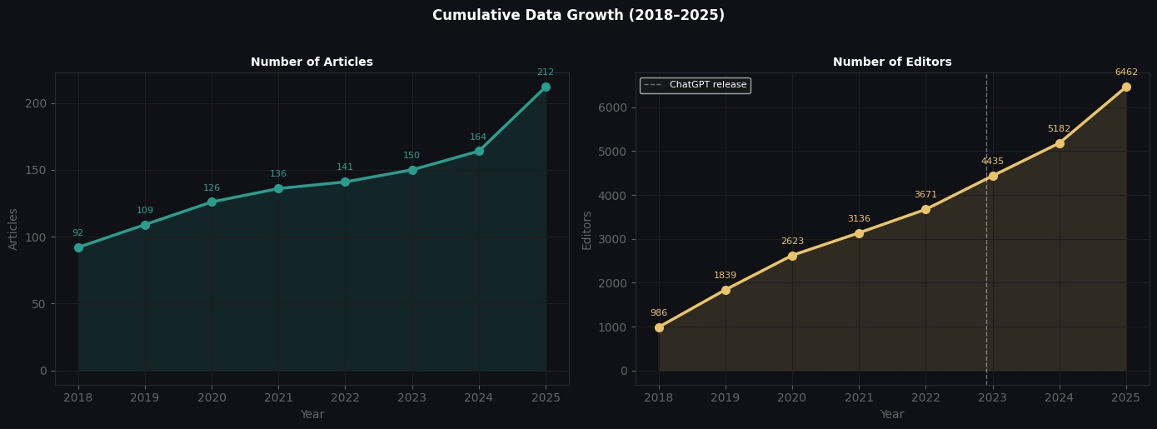
Figure 1. Cumulative growth in articles and editors from 2018 to 2025. The white dashed line marks November 2022 (ChatGPT release).
4.2 Centrality Analysis
All four centrality metrics produce a consistent picture of editorial hierarchy (Figure 2). Maxeto0910 ranks first across all four measures: degree centrality 0.678, betweenness centrality 0.240, PageRank 0.058, and closeness centrality 0.753. These scores indicate that Maxeto0910 holds direct connections with 67.8 percent of all editors in the network, sits on 24 percent of all shortest paths, and reaches every other editor in an average of just 1.33 steps.
The top five positions, occupied by Maxeto0910, Jarble, Headbomb, Alenoach, and MrOllie, show remarkably consistent ordering across all four metrics. This points to a small, well defined core that effectively serves as the backbone of the network.
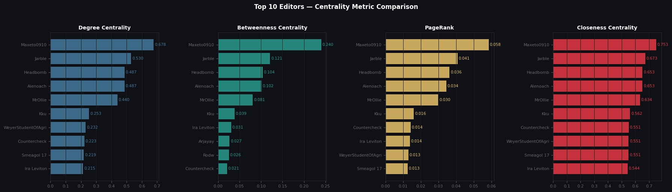
Figure 2. Top 10 editors compared across four centrality metrics. The top 5 ranks are stable across all measures.
4.3 Ego Network Analysis
The ego network centered on Maxeto0910 (Figure 3) makes the dominance of this editor visually apparent. The ego network includes 316 editors, or 67.9 percent of the main network. In other words, nearly two thirds of the editors in the network are just one step away from Maxeto0910. The strongest neighbors (Jarble, Headbomb, Alenoach, MrOllie) are also the editors with the highest degree values across the network as a whole.
This pattern is the visual signature of what is sometimes called a starburst structure: connections radiate outward from Maxeto0910 to almost every region of the network.
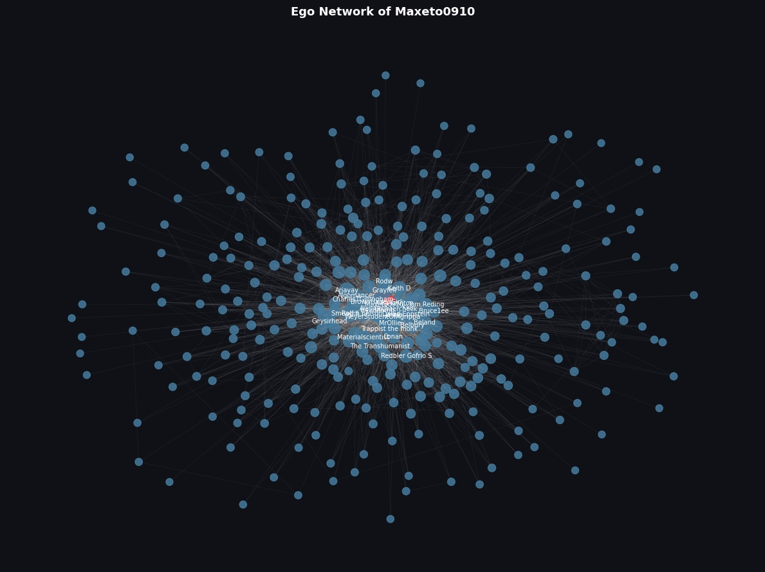
Figure 3. Ego network centered on Maxeto0910. The red node represents the central editor; blue nodes show the 316 directly connected editors.
4.4 Community Structure
The Louvain algorithm defined 7 communities (Figure 4). The modularity score came to Q equal to 0.214, which falls below the 0.30 significance threshold proposed by Newman. This indicates that community boundaries are porous and that editors interact intensively across communities.
The three largest communities (115, 98, and 79 editors) together cover roughly 62 percent of all editors. Their respective leaders are Headbomb, Jarble, and MrOllie.
In other words, the editors at the top of the centrality rankings serve as the gravitational centers of different communities. The interdisciplinary nature of AI topics likely contributes to this pattern: subfields such as machine learning, ethics, philosophy, and applications draw editors with different backgrounds into the same articles.

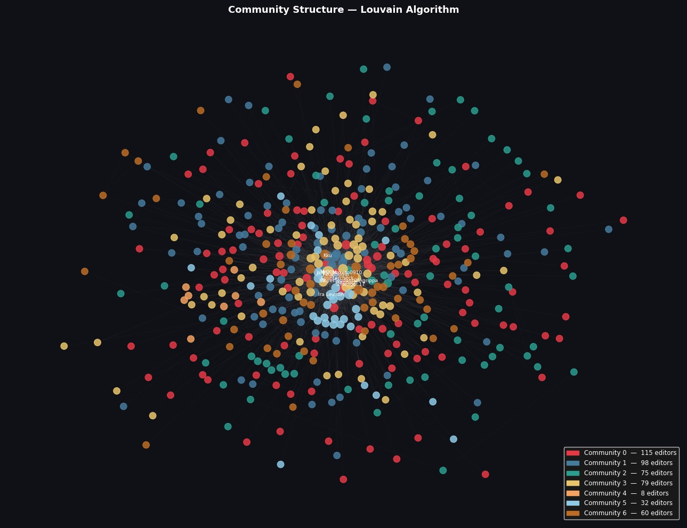
Figure 4. Community structure identified by the Louvain algorithm. The seven colors represent the seven communities. The visible mixing of colors illustrates the porous nature of community boundaries.

4.5 Small World Test
The Watts Strogatz test produced sigma equal to 0.212. Since sigma is below 1, the network does not exhibit small world properties. The detailed comparison reveals the following:
Clustering coefficient (real): 0.075
Clustering coefficient (random): 0.512, meaning the real network is 6.8 times less clustered than the random equivalent
Average path length (real): 2.28
Average path length (random): 3.29, meaning paths are similar (real paths are even slightly shorter)
These results are textbook signs of a core periphery topology. A small number of hub editors (Maxeto0910 and others) connect the entire network, while peripheral editors do not form connections with each other and rely entirely on the core to participate in the network.

4.6 Network Robustness Test
The robustness test removed the 20 editors with the highest betweenness centrality one by one (Figure 5). The results are striking:
Removing only Maxeto0910 fragments the network from a single component into 19 distinct components.
Removing the first 6 hubs results in 52 components.
Removing 20 hubs disconnects 133 editors (28.5 percent of all editors) from the main connectivity.
These results offer numerical evidence that the Wikipedia AI editor community is highly dependent on a small number of committed users and that it is fragile in the face of external shocks.

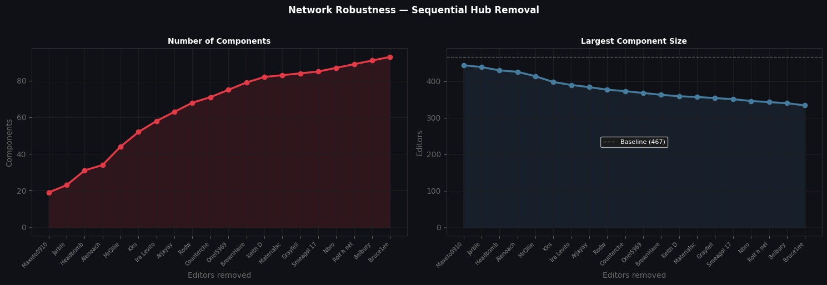
Figure 5. Network changes as hub editors are removed sequentially. Left: rapid increase in component count. Right: contraction of the largest component.

4.7 Temporal Evolution
Yearly snapshot analysis between 2018 and 2025 tracked six core network metrics (Figure 6). Editor count rose from 26 to 467 and edge count climbed from 29 to 3,705. Growth accelerated after 2022: the node count, which stood at 218 in 2022, reached 467 by 2025, increasing by a factor of 2.1.
What stands out, however, is the qualitative change in growth. Network density declined steadily, falling from 0.089 to 0.034. Clustering coefficient dropped from a 2019 peak of 0.168 to 0.075 in 2025. This suggests that the core community structure has been thinning out, with new connections from incoming editors weakening the existing dense fabric.
Average path length stayed nearly constant in the 2.18 to 2.36 range. So while the network has lost some clustering, it has held onto its small world feeling, at least in terms of how quickly editors can reach one another.
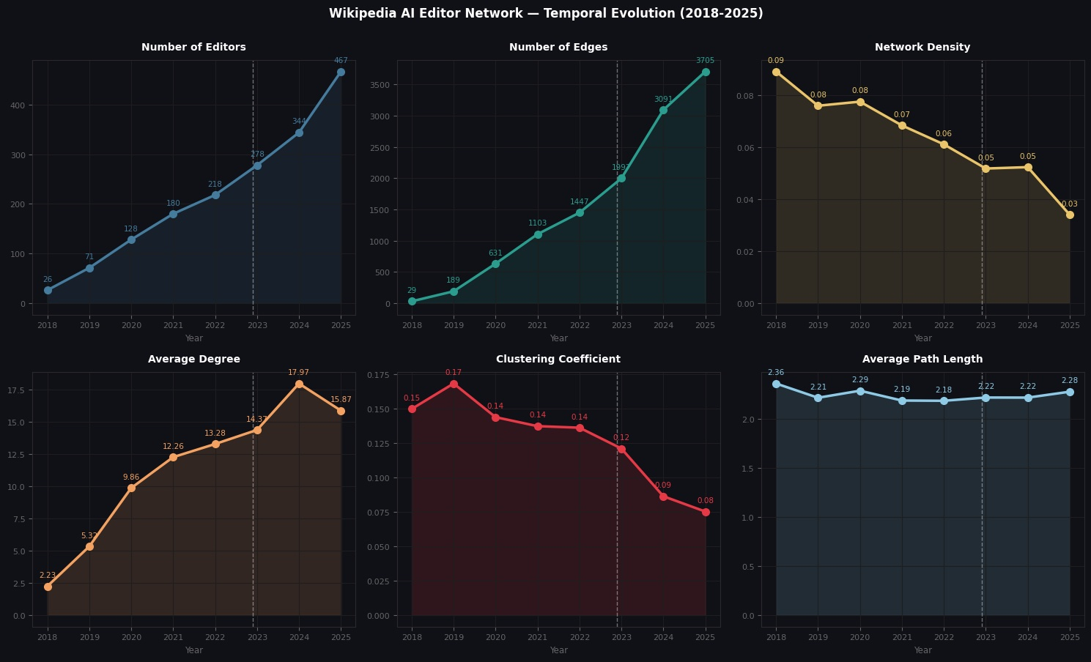
Figure 6. Evolution of yearly network metrics from 2018 to 2025. The white dashed line marks the period when ChatGPT became widely used.

4.8 Cohort Analysis
Editor cohort analysis compares the average degree values in 2025 of editors who first appeared in different years (Figure 7). The findings are dramatic:
2018 cohort (oldest editors): average degree 46.1 > 2022 cohort: 17.0
2024 cohort: 9.7 > 2025 cohort (most recent arrivals): average degree 5.8
An editor who joined in 2025 has roughly one eighth the connectivity of an editor who joined in 2018. The sharpest break occurs in 2024: average degree dropped from 17.3 in 2023 to 9.7 in 2024, then to 5.8 in 2025.
This indicates that despite the large number of new editors arriving alongside the ChatGPT wave, the existing core community has not really integrated them, or that integration processes are simply taking longer than they used to.
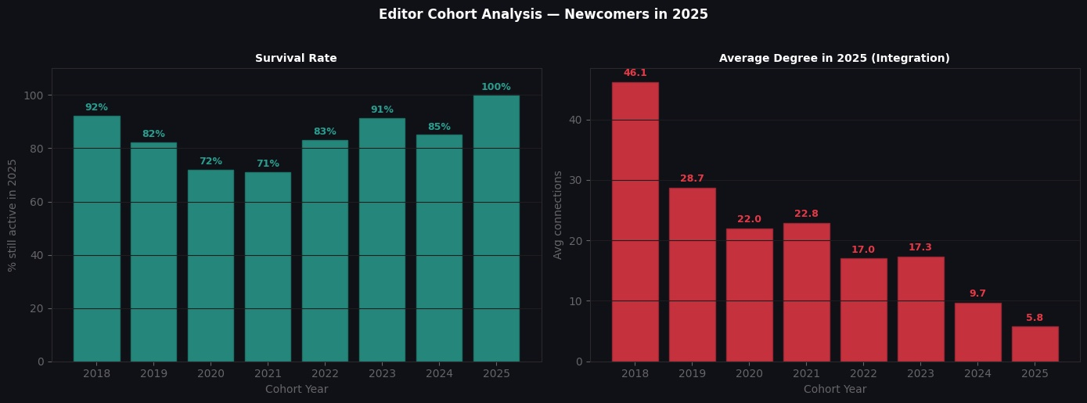
Figure 7. Editor cohort analysis. Left: survival rate. Right: average degree in 2025, showing the staircase like decline in connectivity from 2018 to 2025.
5. Discussion
5.1 What Hub Dependency Means
The fact that Maxeto0910 and Jarble occupy the top positions across all four centrality metrics is unusual. In typical social networks, different metrics tend to highlight different people. One person might be popular (high degree), another might serve as a bridge (high betweenness). Here the same individuals fulfill every role. This points to an extraordinarily concentrated distribution of power.
The robustness test reveals the structural consequences of this situation: removing a single editor (Maxeto0910) breaks the network into 19 components. This single point of failure risk represents a real concern for Wikipedia platform management. The 'power of the few' phenomenon described by Kittur and colleagues reaches an unusually extreme level here.
5.2 Absence of Small World and Core Periphery Structure
The absence of small world properties (sigma equal to 0.21) sets this network apart from many other collaboration networks. The most plausible explanation is the breadth of the AI category. Because AI spans computer science, philosophy, ethics, history, and popular culture, editors with very different backgrounds end up working on the same articles.
This produces a network that is broad rather than deep, marked by high overall connectivity and low local clustering. Editors do not form local communities. Instead, universal hub editors tie the entire network together. This is the classic signature of a core periphery topology.
5.3 The Post ChatGPT Integration Problem
Reeves and colleagues (2024) reported that ChatGPT did not produce a significant general effect on Wikipedia. Our findings differ from theirs in two important ways.
First, the effect on the AI domain is clearly visible: the cumulative editor count rose from 3,671 in 2022 to 6,462 in 2025. The Reeves team examined general Wikipedia metrics and could not detect these domain specific changes. This underscores the importance of focused, domain level analyses.
Second, and more concerning, the new arrivals are not integrating. The 2025 cohort has an average degree of 5.8, which is one eighth of the 2018 cohort's average. This may signal that the existing core community has a difficult relationship with newcomers, or that integration mechanisms are not working as well as they used to. It can be read as a specific manifestation, within the AI cluster, of the broader 'rise and decline' pattern documented by Halfaker and colleagues.
5.4 Community Permeability
The low modularity score (0.21) indicates porous community boundaries. This looks like a negative version of the pattern Rychwalska and colleagues described: those authors found that high quality articles emerge from communication networks combining both local and global connectivity. Here, editors generally touch every community but do not embed deeply in any particular one.
The interdisciplinary nature of AI topics contributes to this. Discussions involving ethical, technical, philosophical, and political dimensions all at once tend to bring together very different editor profiles in the same articles.
5.5 Limitations
Several limitations should be acknowledged.
Sample size: The study is limited to 186 articles. This sample may not represent the entire AI cluster. Subcategories such as Machine learning and Computer vision were not included.
Edge definition: Treating co article contributions as edges does not distinguish constructive collaboration from edit warfare. Two editors who fought over a page would still produce a strong edge between them.
Bot detection: The username heuristic for bot detection cannot identify semi automated accounts that do not advertise themselves clearly.
Excluded articles: The exclusion of five large articles reflects a methodological choice. The internal network structure of those articles was not separately examined.
6. Conclusion
This study mapped the social structure of the English Wikipedia AI editor community for the period 2018 to 2025 using social network analysis methods. The main findings are:
(1) Extreme hub dependency: Maxeto0910 and Jarble occupy the top positions across all four centrality metrics. This concentration of power represents an unusually extreme example of the 'power of the few' pattern in network theory.
(2) Core periphery structure: With sigma equal to 0.21 the network does not show small world properties. It instead consists of a small group of central editors loosely connected to a peripheral layer.
(3) Structural fragility: Removing a single hub editor splits the network into 19 components. This is a sign of high fragility.
(4) ChatGPT effect: The 2023 to 2025 period saw a clear surge in new editor arrivals, but the newcomers have not integrated into the existing community.
(5) Integration crisis: The 2025 cohort has roughly one eighth the average connectivity of the 2018 cohort.
These findings contribute to our understanding of how open collaboration platforms organize around contested knowledge domains exposed to external shocks. The relationship between hub dependency and platform fragility, and the effectiveness of new editor integration mechanisms, should be focal points for future work. Possible extensions include broadening the article sample, adding edit quality metrics, separately analyzing subcategories, and comparing AI communities across different language editions of Wikipedia.

Reproducibility
All analyses in this study were carried out in Python within a Jupyter Notebook environment. Data were collected in January 2026. Because Wikipedia is updated continuously, the same API queries may produce slightly different results at different points in time.
Libraries used: mwclient (Wikipedia API), networkx (network analysis), python-louvain (community detection), pandas, numpy, matplotlib.
Random seed values: Watts Strogatz random graph generation used seed 42. Spring layout also used seed 42.
Dataset: 186 articles, 20,636 revisions (after filtering), covering the 2018 to 2025 time range.
References
- Wikimedia Foundation (2025). Wikimedia Statistics. https://stats.wikimedia.org
- Kittur, A., Chi, E., Pendleton, B. A., Suh, B., and Mytkowicz, T. (2007). Power of the few vs. wisdom of the crowd: Wikipedia and the rise of the bourgeoisie. Proceedings of ACM CHI 2007, 1 to 9.
- Halfaker, A., Geiger, R. S., Morgan, J. T., and Riedl, J. (2013). The rise and decline of an open collaboration system: How Wikipedia's reaction to popularity is causing its decline. American Behavioral Scientist, 57(5), 664 to 688.
- Viegas, F. B., Wattenberg, M., and Dave, K. (2004). Studying cooperation and conflict between authors with history flow visualizations. Proceedings of ACM CHI 2004, 575 to 582.
- Ren, Y., Zhang, H., and Kraut, R. (2023). How did they build the free encyclopedia? A literature review of collaboration and coordination among Wikipedia editors. ACM Transactions on Computer-Human Interaction.
- Barabasi, A.-L., and Albert, R. (1999). Emergence of scaling in random networks. Science, 286(5439), 509 to 512.
- Watts, D. J., and Strogatz, S. H. (1998). Collective dynamics of small world networks. Nature, 393(6684), 440 to 442.
- Blondel, V. D., Guillaume, J.-L., Lambiotte, R., and Lefebvre, E. (2008). Fast unfolding of communities in large networks. Journal of Statistical Mechanics: Theory and Experiment, 2008(10), P10008.
- Newman, M. E. J., and Girvan, M. (2004). Finding and evaluating community structure in networks. Physical Review E, 69(2), 026113.
- Reeves, N., Yin, W., and Simperl, E. (2024). Exploring the impact of ChatGPT on Wikipedia engagement. arXiv preprint.
- Rychwalska, A., et al. (2025). Quality teamwork on Wikipedia: Interpersonal communication networks as a social capital booster. Journal of the Association for Information Science and Technology.
- Brandes, U. (2001). A faster algorithm for betweenness centrality. Journal of Mathematical Sociology, 25(2), 163 to 177.
- Page, L., Brin, S., Motwani, R., and Winograd, T. (1999). The PageRank citation ranking: Bringing order to the web. Stanford InfoLab Technical Report.
- Kittur, A., and Kraut, R. E. (2008). Harnessing the wisdom of crowds in Wikipedia: quality through coordination. Proceedings of CSCW 2008, 37 to 46.
- Suh, B., Convertino, G., Chi, E. H., and Pirolli, P. (2009). The singularity is not near: Slowing growth of Wikipedia. Proceedings of WikiSym 2009, Article 8.
Appendix A: Articles Excluded from Scope
The following five articles were excluded from the network analysis due to their high editor counts (over 300). Reasoning: in such crowded articles, the so called 'collaboration' between hundreds of editors does not actually represent shared work. It mostly reflects individual interventions made over many years by people who never really worked together. Including these articles would also add over 1.1 million edges, drowning out the genuine collaboration patterns.
1. Artificial intelligence, 1,504 editors
2. Artificial general intelligence, 485 editors
3. Game theory, 460 editors
4. Graphics processing unit, 372 editors
5. Ethics of artificial intelligence, 340 editors

Appendix B: Top 20 Most Central Editors
The table below lists the top 20 editors ranked by the average of their positions across the four centrality metrics.
Rank | Editor | Degree | Betweenness | PageRank | Closeness
1 | Maxeto0910 | 0.678 | 0.240 | 0.058 | 0.753
2 | Jarble | 0.530 | 0.121 | 0.041 | 0.673
3 | Headbomb | 0.487 | 0.104 | 0.036 | 0.653
4 | Alenoach | 0.487 | 0.102 | 0.034 | 0.653
5 | MrOllie | 0.440 | 0.081 | 0.030 | 0.634
6 | Kku | 0.253 | 0.039 | 0.016 | 0.562
7 | Countercheck | 0.223 | 0.021 | 0.014 | 0.551
8 | Ira Leviton | 0.215 | 0.031 | 0.014 | 0.544
9 | Smeagol 17 | 0.219 | 0.016 | 0.013 | 0.551
10 | WeyerStudentOfAgrippa | 0.232 | 0.011 | 0.013 | 0.551
11 | BrownHairedGirl | 0.184 | 0.019 | 0.011 | 0.538
12 | Arjayay | 0.176 | 0.027 | 0.011 | 0.531
13 | Materialscientist | 0.165 | 0.016 | 0.010 | 0.531
14 | Belbury | 0.184 | 0.008 | 0.011 | 0.533
15 | Rolf h nelson | 0.176 | 0.009 | 0.010 | 0.533
16 | Onel5969 | 0.158 | 0.019 | 0.009 | 0.520
17 | Keith D | 0.150 | 0.017 | 0.009 | 0.517
18 | Rodw | 0.139 | 0.026 | 0.008 | 0.514
19 | Grayfell | 0.135 | 0.016 | 0.010 | 0.517
20 | Nbro | 0.148 | 0.007 | 0.008 | 0.520

